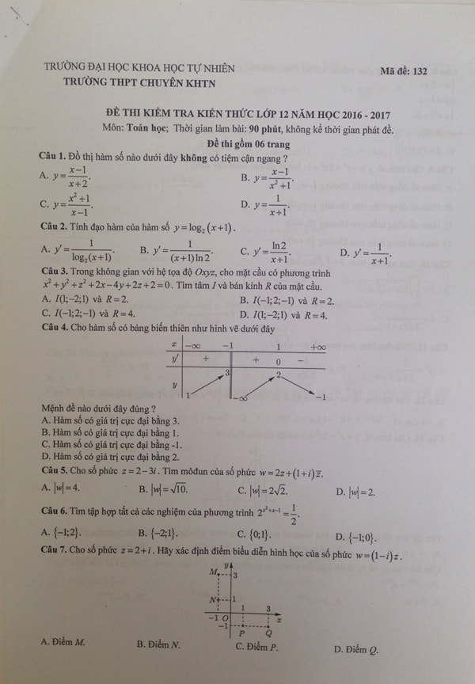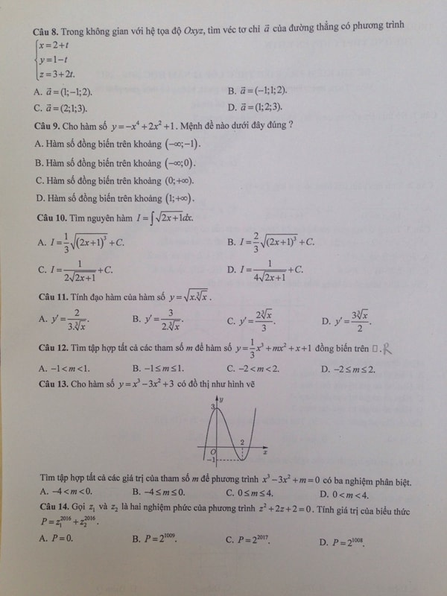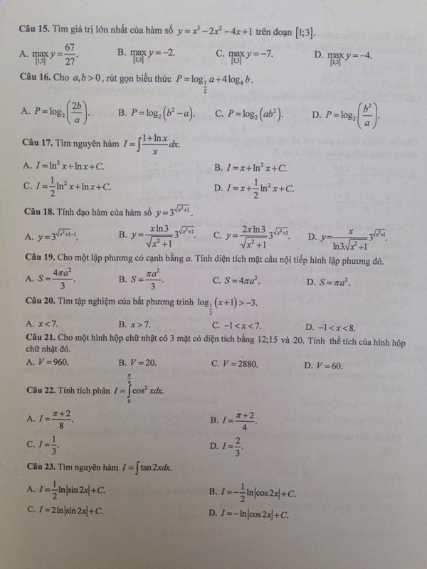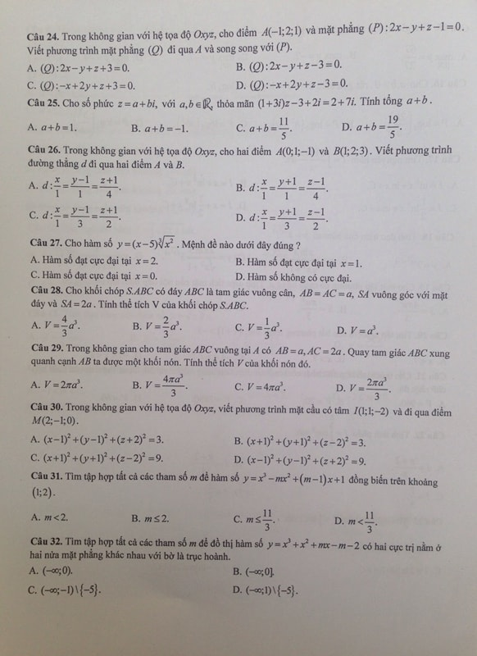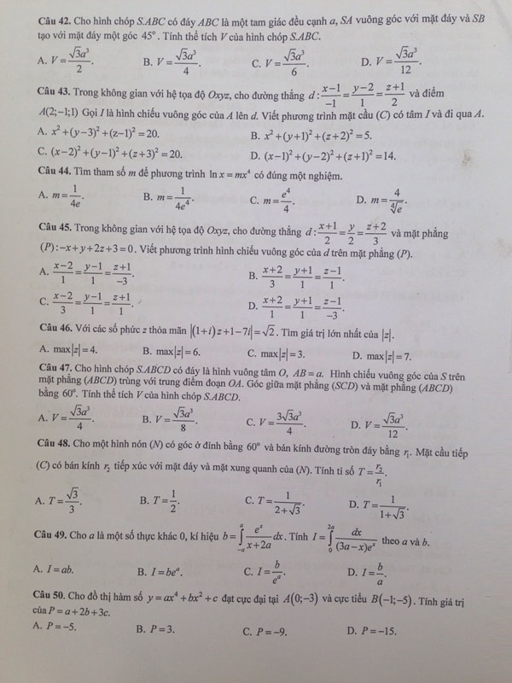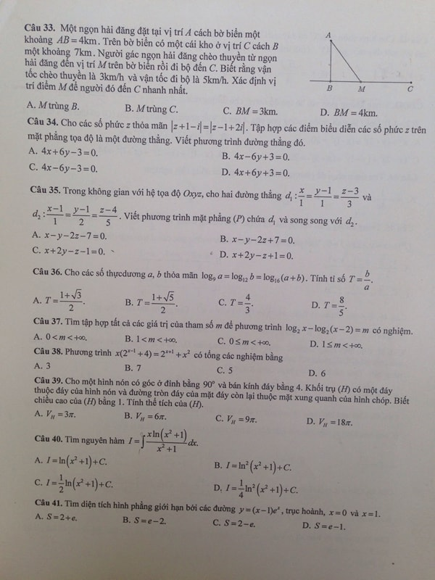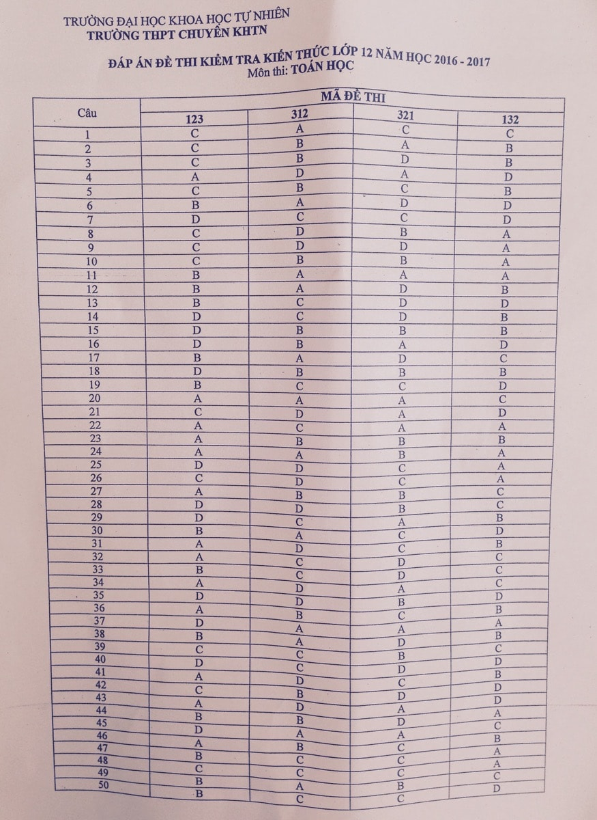

Nguồn: <http://dethikiemtra.com/lop-12/de-thi-thu-thpt-quoc-gia/de-thi-thu-thpt-quoc-gia-mon-toan-nam-2017-truong-thpt-chuyen-khoa-hoc-tu-nhien-dh-quoc-gia-d13733.html>

Xem thêm: <http://dethikiemtra.com/lop-12/de-thi-thu-thpt-quoc-gia>